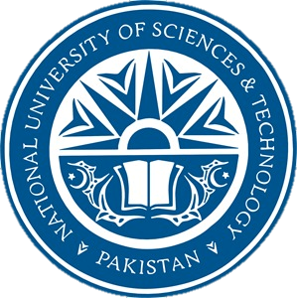

***School of Mechanical & Manufacturing Engineering (SMME),***

***National University of Science and Technology (NUST),***

***Sector H-12, Islamabad***

**Program**: BE-Mechanical **Section**: ME-15 B

**Session**: Fall 2023 **Semester**: 1st

**Course Title**: Fundamentals of Programming

**Lab Manual #8:**

***“________________ARRAYS__________”***

***Name: SYED ALI NAQI***

***CMS:*** 466889

**TASK 1:**

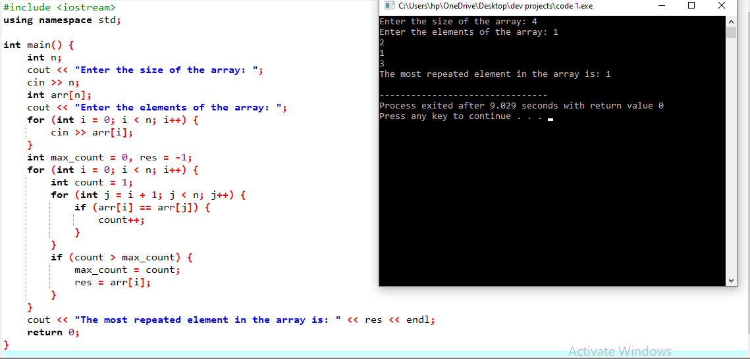

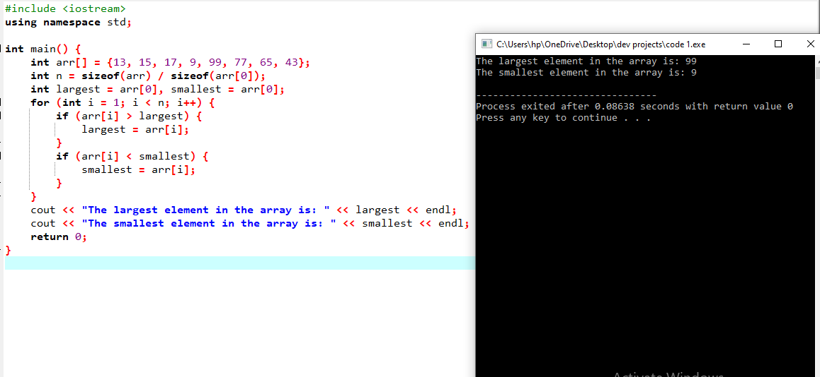**TASK 2:**

**TASK 3:**

